ANA-050 Functional Specification
Simpsons Beverages: Schedule Number Generation V2.0

Document Properties
Authors | Eshan Fernando | Infor M3 Consultant

Approvers | Joe Walker | Solution Architect | Date: 24/10/2025
Approvers | Bevon Raj | Senior Consultant | Date: 24/10/2025

Change Control | Eshan Fernando | Creation | Date: 24/10/2025
Change Control | Eshan Fernando | Display next available schedule number in the sequence against the production line | 28/11/2025
Change Control |  |  | Date

Contents
ANA-050 Functional Specification 1
Document Properties 1
Contents 1
Introduction 2
Functional Overview 2
Current process 2
Proposed process 2
Below is the sequence in which APIs are executed. 5
Assumptions & Limitations 7

Introduction
This ANA-050 Functional Specification provides a functional solution for the Schedule Number Generation V2.0 requested by Simpsons Beverages.
It is not intended to provide technical information. Any supporting technical information can be found in the accompanying ‘TAR-040 Technical Specification’ document, if provided.

The primary objective of this specification is to provide a functional overview of a solution to the proposed modification.

It does not consist of any training material that explains to a detailed level how the deliverables form the functional solution. It is expected that the reader of this document is to have a good understanding of any Infor M3 programs mentioned within this specification.

Functional Overview

Current process
Currently, Simpsons does not maintain separate planned and confirmed orders in their planning process. The practice is to calculate daily production requirements on a spreadsheet and translate it to a production plan. On the production plan, production orders are sequenced based on a range of factors. These factors include the inclusion of certain elements on the recipe (Such as gum), packaging needed, customer the order is intended for etc. Once the production sequence is finalized for the day, it is then followed by the employees on the production floor.

Below is a sample production plan followed by the packaging team.

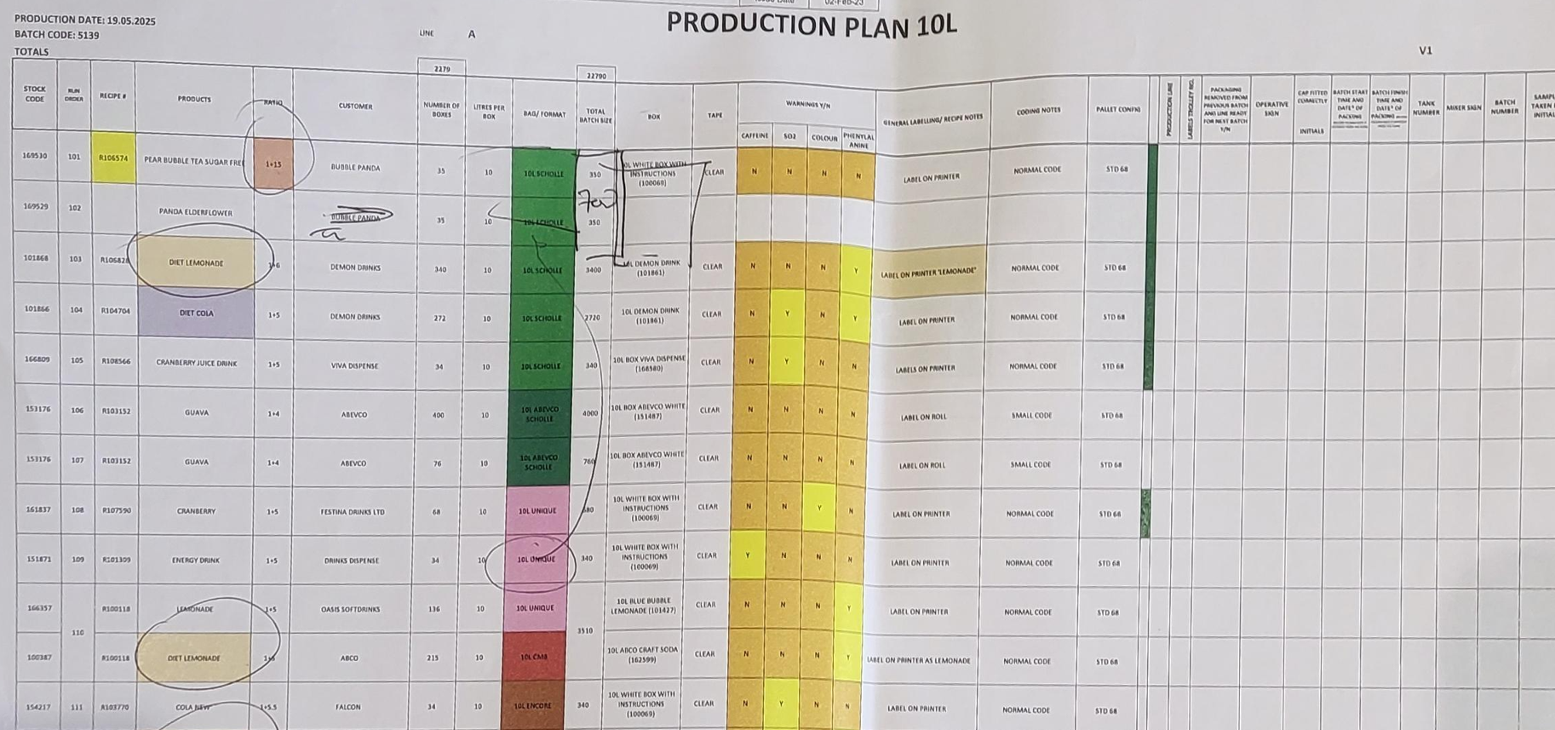
Figure 1: Current production plan.

Proposed process
Production planning and scheduling in Infor Cloudsuite happens during the planning stage. Material Requirements Planning (MRP) engine in Infor Cloudsuite works in such a way that it considers customer demand, sales forecast, existing orders, stock levels and suggests production proposals respecting lead time so that production planners could review and release proposals to the production floor as a confirmed plan. To achieve a confirmed plan, production planners are given visibility to information such as the packaging needed, customer the order it is intended for, inclusion of a gum item on the custom list view built for planning. Production planners will also consider factors such as material shortages and capacity requirements to sequence production proposals by assigning schedule numbers.

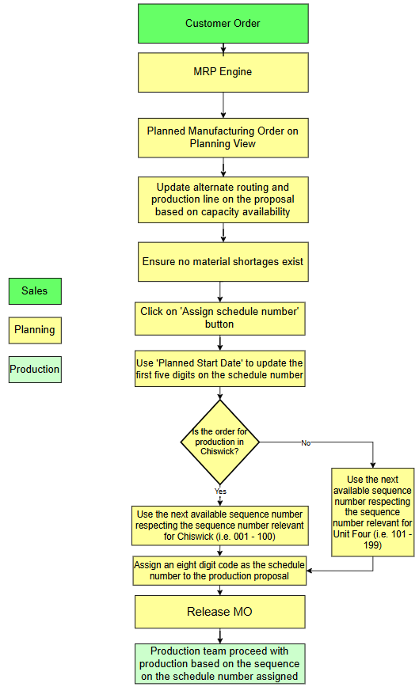
Figure 2: Proposed planning process.

There will also be a display on the planning view showing the next available schedule number based on the production line entered. The next available schedule number is calculated by adding one to the latest schedule number on the list of proposals within the production line which has a release date of today.
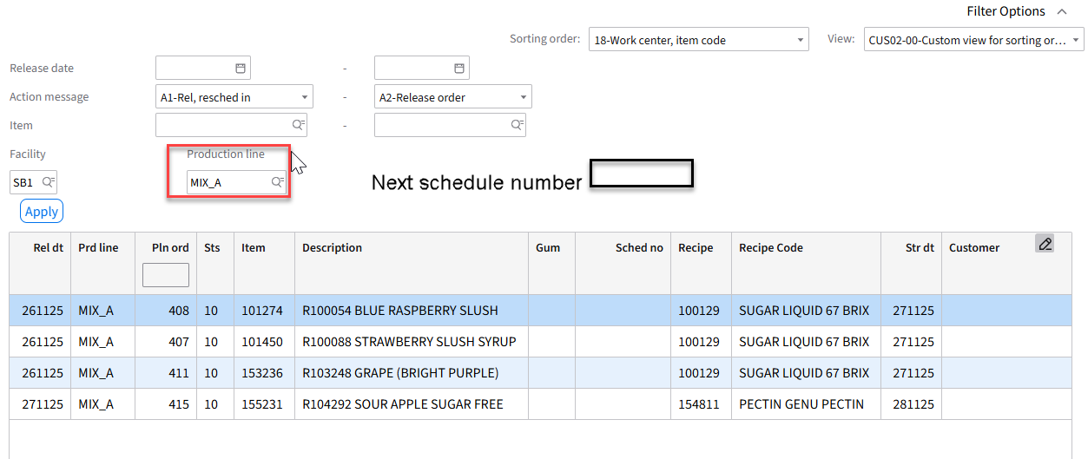When sequencing production proposals in Infor Cloudsuite, a system-generated sequence number is attached to each production proposal. However, as per standard behavior, this is an incremental number that automatically resets once it reaches a specific number (i.e. 999). Instead of using the standard schedule number proposed by Infor Cloudsuite, Simpsons Beverages wish to use a custom schedule number for each of their two production areas, namely Chiswick House and Unit Four. To facilitate this requirement a development is proposed which generates a schedule number respecting the following pattern.

 | First five digits on the schedule number | Final three digits on the schedule number | Sample
Chiswick House | Julian day code in YYNNN format based on the planned start date on the proposal | Sequence number that is representative of Chiswick House | 25296001
Unit Four | Julian day code in YYNNN format based on the planned start date on the proposal | Sequence number that is representative of Unit Four | 25296101
Figure 3: Proposed schedule numbering logic for Chiswick House and Unit Four.
Below is the formation logic for the schedule number.

‘Assign Schedule Number’ button is implemented on the custom list view built for planning. When a production planner clicks on it, a schedule number is attached to a production proposal. In the event multiple production proposals are selected and ‘Assign Schedule Number’ button clicked, all production proposals selected will be assigned the schedule number attached to the first production proposal in the selection. Julian day code on the schedule number is calculated based on the start date on the first production proposal in the selection. Based on the Julian day code and the production line, Infor Cloudsuite then performs a check to identify the next available sequence number and assigns it to (the) production proposal(s). 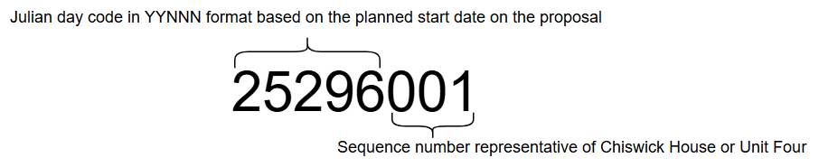

Step 04: Calculate the schedule number.
Based on Table 6 output, the next available sequence number is calculated. While planned start date (ROSTDT) on the first proposal in the selection determine the first five digits (Julian Day code in YYNNN format) on the schedule number, the sequence number is calculated by incrementing the latest sequence number on Table 6 by one. Sequence number is calculated considering the production line (ROWCLN) in Table 2. If production line is ‘MIX01’ or commences from U4 sequence number would commence from 101 else sequence number commences from 001.

If PRD Line in MIX_A, MIX_B, 10L_A, 10L_B, 10L_C, 500ML, 5L_A, 5L_B, IBC then schedule number last 3 digits would be 001 and if it already exists then just add +1.
After 009 it would 010 and 099 would be maximum confirmed by business.

For any other product line, the sequence number would start as 101, 102 and so on.
199 would be maximum.

Note For each date the schedule number has to start from 001

An example as follows.

Output field on Table 2 | Sample value on Table 2 output field | Digits on the schedule number output field is mapped to | Mapping to schedule number | Sample
ROSTDT | 20251024 | 1-5 | Convert to Julian Day code in YYNNN format | 25297001
ROWCLN | MIX_A | 6-8 | Next available number in the sequence | 25297001

Below is the sequence in which APIs are executed.
When production proposal(s) is(are) selected and ‘Assign Schedule Number’ button clicked on the custom list view for planning, below sequence of APIs needs to be executed. In the event multiple production proposals are selected and ‘Assign Schedule Number’ button clicked they will all be assigned the same schedule number attached to the first production proposal in the selection.

Step 01: Extracting the planned start date and production line on (the) selected production proposal(s).
  - API: CMS100MI
  - Transaction: LstPlannedMO
Description | Field | Test Value | Extraction Method
Planned order | PLPN | 834 | If one planned MO is selected use the planned order number on it, else use the planned order number on the first proposal in the selection.
Table 1: Inputs to extract planned MO details.
Description | Field
Start date | ROSTDT
Production line | ROWCLN
Table 2: Output extracted from CMS100MI: LstPlannedMO.
The planned start date extracted on Table 2, needs to be used to extract the Julian Day code.

Step 02: Extract the Julian Day code applicable to the planned start date on the production proposal.
  - API: CRS900MI
  - Transaction: GetSysCalDate
Description | Field | Test Value | Extraction Method
Date YYYYMMDD | YMD8 | 20251024 | Start date in Table 2.
Table 3: Inputs to obtain the Julian Day code relating to the planned start date.
Description | Field
Day Number YYYYNNN | YDNO
Table 4: Julian Day code extracted from CRS900MI: GetSysCalDate.
Julian Day code extracted from Table 4 needs to be converted to YYNNN format by omitting the first two characters on the output.

Step 03: Retrieving schedule numbers currently in Infor Cloudsuite.
- API: EXPORTMI
- Transaction: Select
Description | Field | Test Value | Extraction Method
Query statement | QERY | HSSCHN from MSCHMA | Hardcoded to HSSCHN from MSCHMA
Table 5: Inputs to extract schedule numbers created.
Based on inputs to Table 5, below outputs are obtained.

Description | Field | Test Value
Reply Field | REPL | 25297001
Table 6: Output from EXPORTMI: Select
Table 7: Calculation of schedule number.

While running the update api for multiple selected records use the PLPN for each record as input to the api

Step 05: Assigning schedule number(s) to the production proposal(s).
  - API: PMS170MI
  - Transaction: Updat
Description | Field | Test Value | Extraction Method
Planned order | PLPN | 834 | Use the planned order number based on the production proposal(s) selected on the custom list view for planning. If multiple production proposals are selected, feed the proposal number one after the other in a loop
Schedule number | SCHN | 5296001 | Schedule number calculated in Step 03.
Table 8: Inputs to assign schedule number(s) to the selected planned order(s).

Step 06: Delete schedule numbers in PMS270 in Infor Cloudsuite at the end of the century/ beginning of a new century using an Infor Process Server (IPS) deletion API.
This needs to be scheduled to run after working hours on December 31st at the end of the century (i.e. 2099) or before working hours on January 1st beginning of the century (i.e. 2100).

Step 07: Display the next available schedule number in the sequence for the production line entered.
  - API: CMS100MI
  - Transaction: LstPlannedMOs
Description | Field | Test Value | Extraction Method
From Release Date | F_RELD | 20251128 | Today’s date in YYYYMMDD format
To Release Date | T_RELD | 20251128 | Today’s date in YYYYMMDD format
Facility | FACI | SB1 | Maintain as a configurable parameter if needs expanding later on
Production line | WCLN | MIX_A | Production line filter on the planning view
Table 9: Extract schedule numbers assigned to proposals with a release date of today
Description | Field
Schedule No | ROSCHN
Table 10: Output of all schedule numbers assigned to proposals with a release date of today
Based on the highest schedule number as per Table 10, add one to the sequence number and display the next number in the sequence.

Note: -

Assumptions & Limitations
- Julian day code will be in YYNNN format.
- Schedule numbers in PMS270 will be deleted after working hours at the end of a century or before working hours at the beginning of a century.
- Julian Day code on the schedule number is determined based on the planned start date on the production proposal.
- Sequence number on the schedule number is determined based on the production line on the production proposal and the latest sequence number on schedule numbers already in Infor Cloudsuite.
- If multiple production proposals are selected to ‘Assign Schedule Number’ they will all pick the schedule number attached to the first production proposal in the selection.
- If a mistake is made when assigning schedule numbers to a production proposal, it needs to be handled outside the scope of this development, where the schedule number needs to be deleted and added using the related options on the custom list view for planning.
- The default production line for all manufactured items needs to be maintained against Item/ Facility (MMS003) record.
- Production line and the alternate routing on a production proposal needs to be correct prior to clicking on ‘Assign Schedule Number’ button.
- Schedule numbers in Infor Cloudsuite (PMS270) are not manually updated, deleted.
- ‘Joint scheduling’ related option in PMS170 will be disabled once the development is active.
- ‘Assign Schedule Number’ will be made available in planned MO (PMS170) screen and on the custom list view for planning.
- At least one planned order needs to be selected prior to clicking on ‘Assign Schedule Number’ button.
- Maximum production runs per day in Chiswick House or Unit Four will not exceed one hundred.

